9.4 Affecting rate (Ⅱ)
Name: ____________________ Class: ____________________ Due date: 11.7
1. A simple way of making bread includes
1Mixing flour with a small amount of yeast and some water to make a ‘dough’.
2 Leaving the dough in a warm place for the yeast to act on the dough to form carbon dioxide which increases the volume of the dough.
Which factors affecting a reaction rate are involved in bread making? （ ）
 | temperature | use of an enzyme
A | ✓ | ✓
B | ✓ | ×
C | × | ✓
D | × | ×

2. A student was investigating the reaction between marble chips and dilute HCl
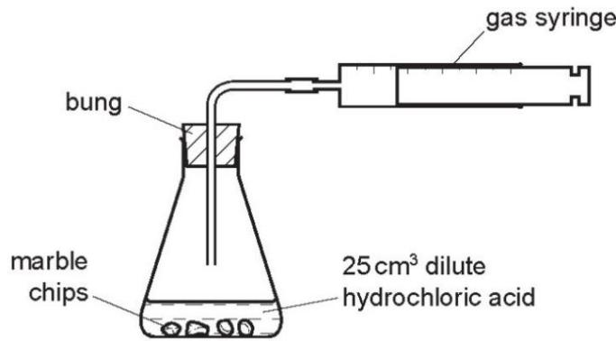
Which changes would reduce the rate of reaction? （ ）
 | temperature of acid | concentration of acid | surface area of marble chips
A | decrease | decrease | decrease
B | decrease | decrease | increase
C | increase | decrease | decrease
D | increase | increase | increase

3. The diagram shows an experiment to measure the rate of a chemical reaction.
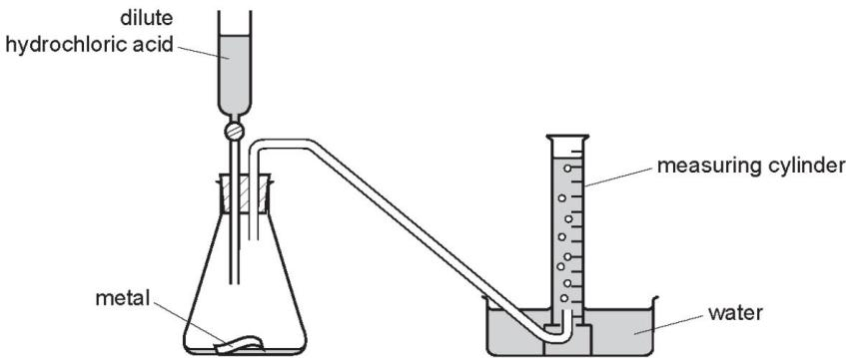
Which change decreases the rate of reaction? （ ）
A adding water to the flask
B heating the flask during the reaction
C using more concentrated acid
D using powdered metal

4. The effects of a change in conditions on a chemical reaction are listed.
1 The total number of collisions per minute increased.
2 The number of effective collisions per minute increased.
3 The average energy of the particles increased.
Which change in conditions caused all of these effects? （ ）
A addition of a catalyst
B increasing the concentration of a solution of a reactant
C increasing the surface area of a solid reactant
D increasing the temperature

5. Which row describes the effects of increasing both concentration and temperature on the collisions between reacting particles? （ ）
 | increasing concentration | increasing temperature
A | more collisions per second only | more collisions per second only
B | more collisions per second and more collisions with sufficient energy to react | more collisions per second only
C | more collisions per second only | more collisions per second and more collisions with sufficient energy to react
D | more collisions per second and more collisions with sufficient energy to react | more collisions per second and more collisions with sufficient energy to react

6. The rate of reaction between magnesium and excess dilute hydrochloric acid was followed by measuring the mass of magnesium present at regular time intervals.
Two experiments were performed.
Both experiments used $0.1g$ of magnesium ribbon.
The acid in experiment 1 was less concentrated than in experiment 2.
Which graph shows the results of the experiments? （ ）
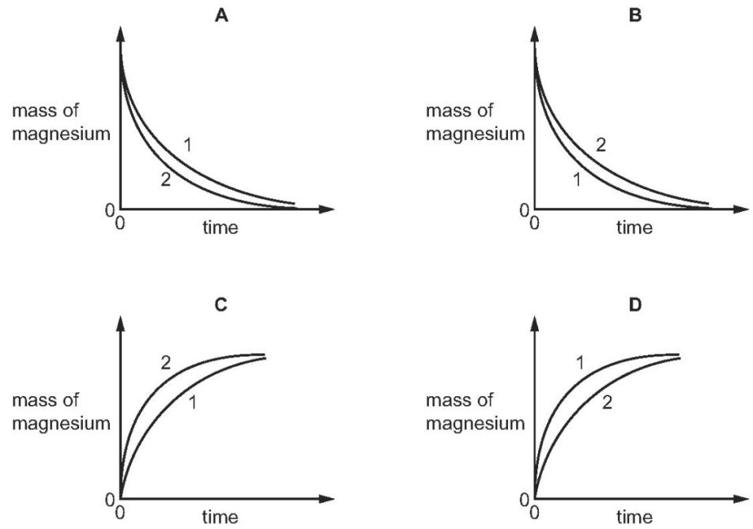

7. Zinc granules are reacted with excess dilute hydrochloric acid.
The volume of hydrogen given off is measured at different times.
The results are shown on the graph, labelled experiment 1.
The results for a second experiment are shown on the graph, labelled experiment 2.
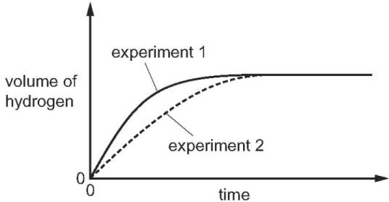
Which change to the conditions was made in experiment 2? （ ）
A The concentration of the hydrochloric acid was decreased.
B The size of the zinc granules was decreased.
C The surface area of the zinc granules was increased.
D The temperature was increased.

8. An excess of calcium carbonate is added to dilute hydrochloric acid, X.
The carbon dioxide gas given off is collected and its volume recorded at regular time intervals.
Line X on the graph shows the results obtained.
The experiment is repeated using dilute hydrochloric acid, Y.
Line Y on the graph shows the results obtained.
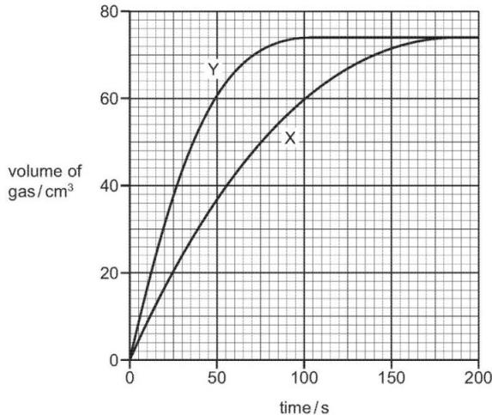
Which statement about the two hydrochloric acid samples, X and Y, is correct?（ ）
A They had the same volume but Y had higher concentration.
B They had the same concentration but Y had a larger volume.
C X had a higher concentration but Y had a larger volume.
D Y had a higher concentration but X had a larger volume.

9. Copper(II) oxide reacts with dilute hydrochloric acid.
$$CuO(s)+2HCl(aq)→{CuCl}_{2}(aq)+H_{2}O(l)$$
6.00g of copper(II) oxide were added to $50.0{\text{cm}}^{3}$ of $1.00{\text{mol / dm}}^{3}$ hydrochloric acid. This was an excess of copper(II) oxide.
The rate of the reaction can be increased by increasing the concentration of the hydrochloric acid or by heating it.
In terms of collisions, explain why increasing the concentration of the hydrochloric acid increases the rate of the reaction.
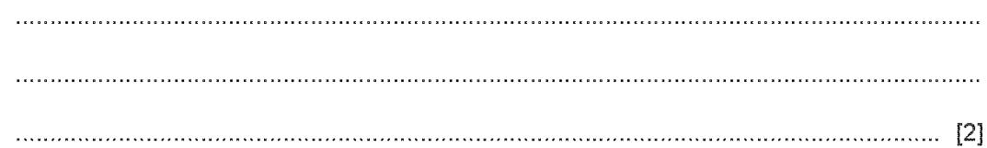
10. $HCI,$ and an excess of large pieces of marble, $CaCO_{3}$ , using the apparatus shown.
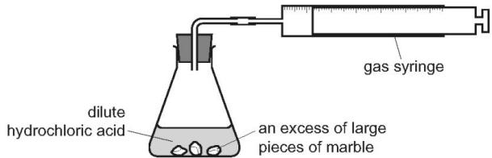
A graph of the volume of gas produced against time is shown.
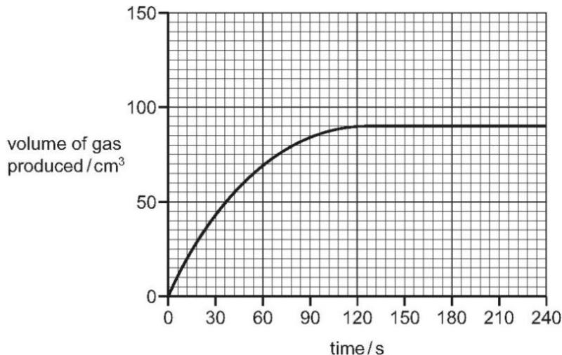
a. How does the shape of the graph show that the rate of reaction decreased as the reaction progressed?
...............................................................................................................................
...............................................................................................................................
...............................................................................................................................
b. Why did the rate of reaction decrease as the reaction progressed?
...............................................................................................................................
...............................................................................................................................
...............................................................................................................................
c. After how many seconds did the reaction finish?................s [1]
d. The experiment was repeated using the same mass of smaller pieces of marble. All other conditions were kept the same.
Draw a graph on the grid to show the progress of the reaction using the smaller pieces of marble. [2]

